**Verification:**

On doing Verification and entering the correct code from my email, this error page appears instead of any confirmation of Verification or redirecting to website.

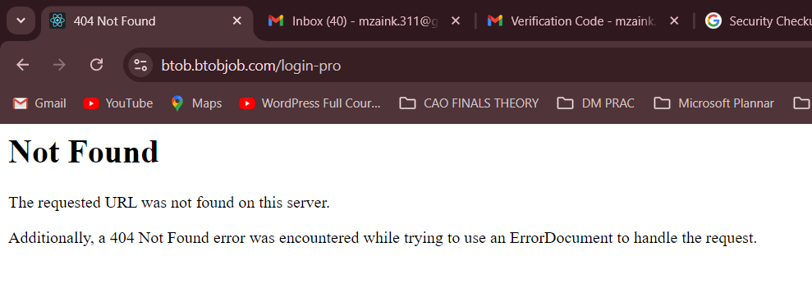

**PROFILE LINK and Business Cards:**Business Card is working but:

* Cover Photo is not appearing on the card
* Link is not working individually, matlab jab hum card download karne ke baad business_card.png wali file khol rahay tou usme jo **Profile Link** hai wou alag se google pe dalne pe nahi khul rahi (in conclusion profile link hi nahi chal rahi).
* Address bhi nahi aa raha Business Card pe.

**Close Button on Verification:**

Close button is not working on the Verification Page.

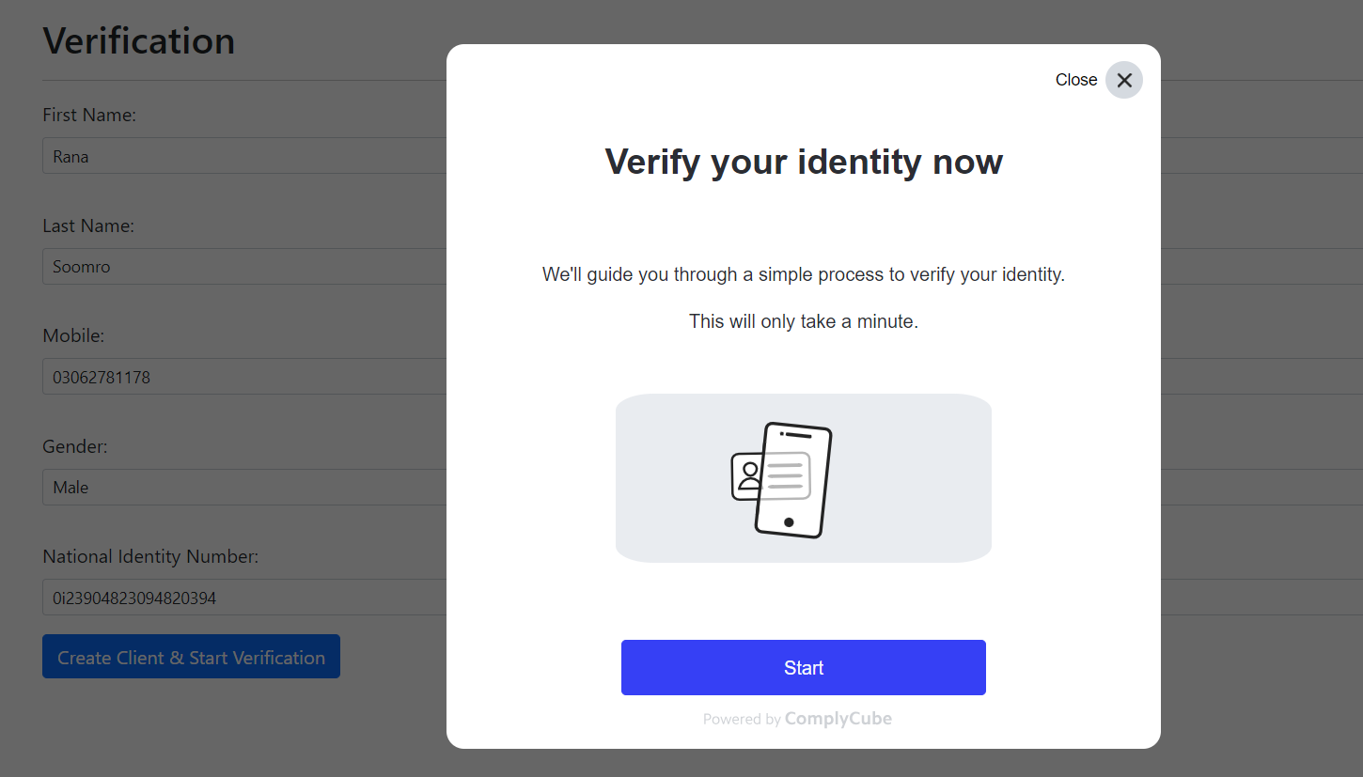



**Page Overlapping:**

Notification menu kholne pe back page overlap horaha, not everywhere but kahin kahin,

Like below:

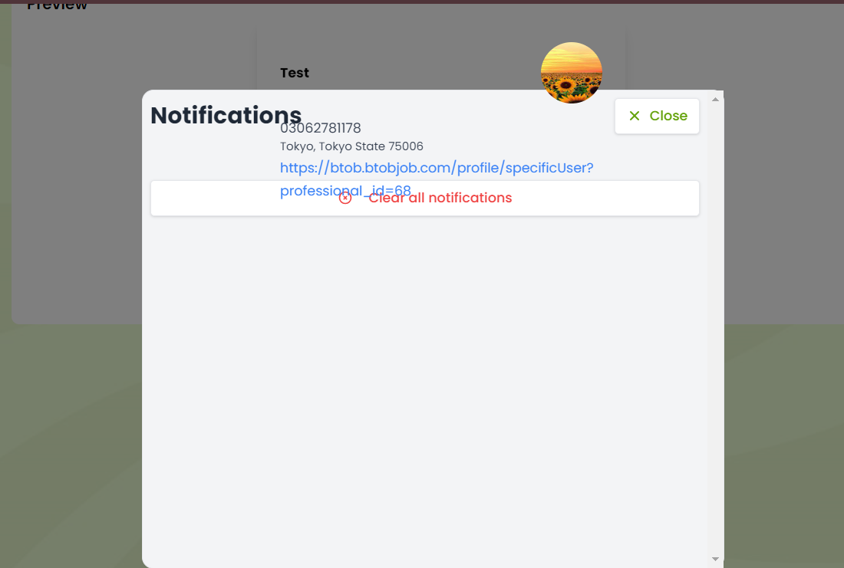

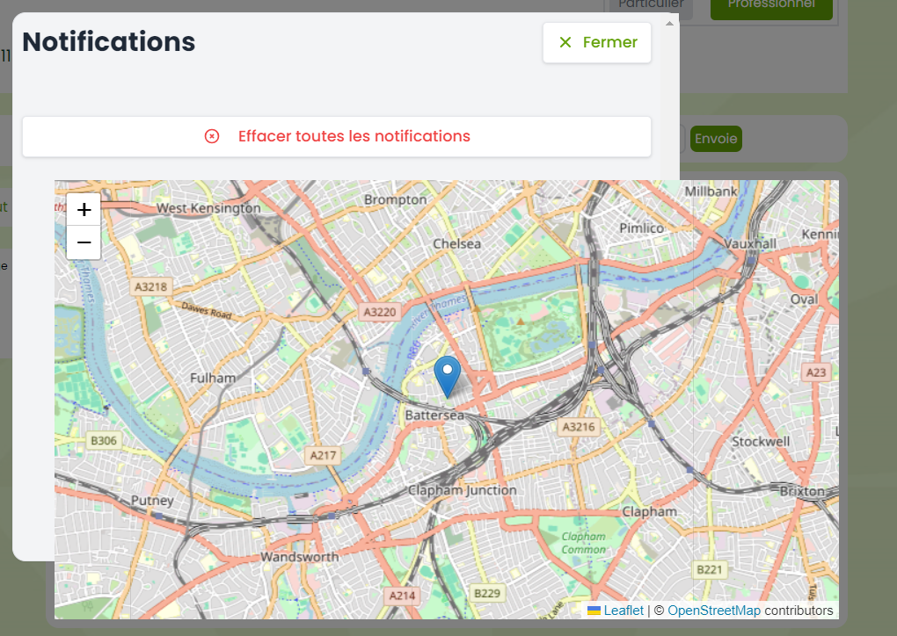

**See the Request:**

See the request/View Request walay page ko kholne pe yeh khul raha:

**Personal Information:**Personal information page ko kholne pe settings or data hamesha saari fields empty aati hen make sure ke fields wohi bhari hui hon jo pehle save ki hui thi.

Plus remove the password field from here as this is a Personal Information Page, isko drop down walay button pe “**Change Password**” ke name se ek button dalden jispe click karne se yeh 3 options ayen:

Type Current Password:  
Type New Password:  
Re-Type New Password:

Plus, Password walay option se Password change nahi horaha still wohi purana wala password se login horaha.

**Accueil / Homepage:**Isko click karne pe kuch open nahi horaha,

Button:

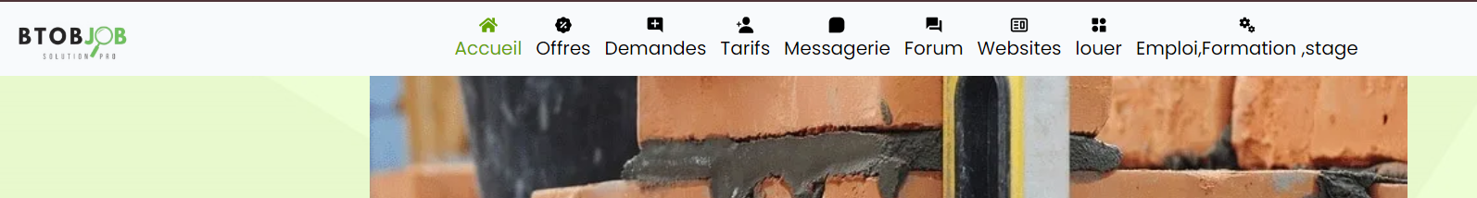



After Clicking:

**Contact Us Page:**This error appears when a query is send on Contact page.

**Menu Bar: “Add a job”**

Job add hi nahi horahi and **Submit** karne pe error aa raha, error page mentioned below:

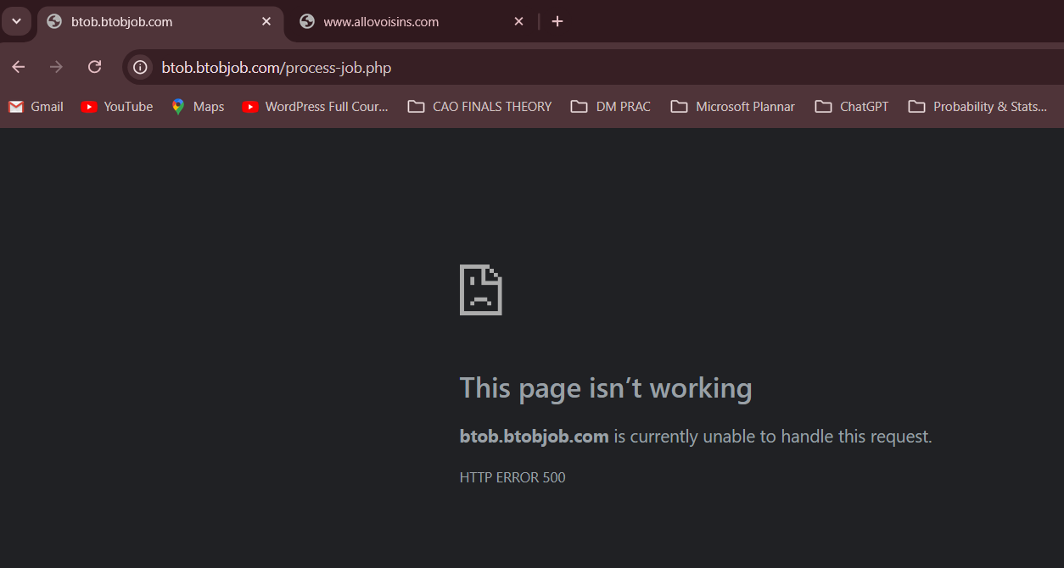

**Profile Bar:**Profile Bar close hojana chiyeh jab hum ispe se mouse ko hata ke kisi orr cheez pe click karen, zaroori nahi ke cross pe click kare, balke screen pe kahin bhi click karne pe yeh Bar close hojaye.

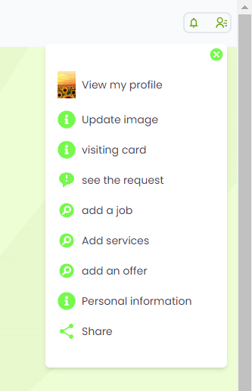

**Replacement of “Rental Equipment” to “Rental Sale” (in French):**

Replace the phrase of **“Rental Equipment”** to **“Rental Sale”**, yeh **“Add Services”** pe click karne ke baad khulta hai isko replace karna hai wording ko.

Plus, yahan pe

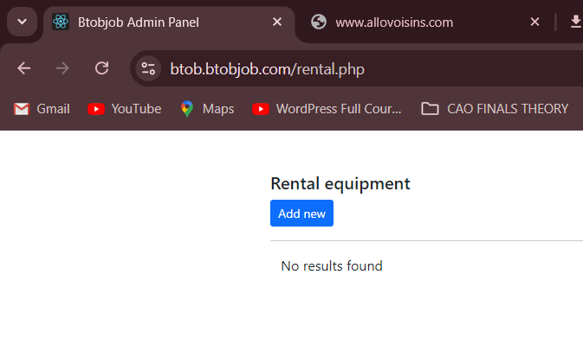

**See The Request button:**

See the request ka button kaam nahi kar raha, error page khul raha (mentioned below in picture).

Or iske saath saath jab hum **“Add an Offer”** kar rahay tou wou upload offer … **“See the Request”** walay page pe bhi aana chiyeh hai likn page hi nhi khul raha or wahan wesey bhi nahi aa rahi wo request (offer) jo hum daal rahay.

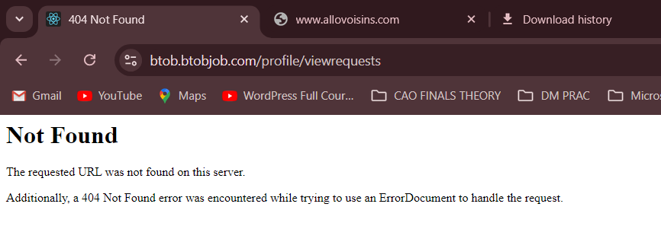

**Accueil (Homepage):**

Homepage or Accueil Page ek tou kaam nahi kar raha, click karne pe ya kholne pe jab uspe Request walay button pe click kiya jaata tou koi functionality nahi hai uss button pe. Jab ke usko click karne pe Public Request wala box khuljana chyh jisme saari request karke “Post Request” kar saktay.

**Private Request:**

Private Request ka request box khulne pe jab hum request post kar rahay tou kaafi time lag raha response aanay me (button click karne ke baad ka response).

Plus kisi private request ko daalne ke baad **“Messages”** walay tab me aana chiyeh but wahan kuch nahi aa raha.

**Public Request:**

Public Request ka request box khulne pe jab hum request post kar rahay tou kaafi time lag raha response aanay me (button click karne ke baad ka response).

Public Request jo bhi banda dalay ga wo request Accueil (Homepage) pe aani chiyeh but wahan kuch nahi aa raha request dalne ke baad.

**Rates/Subscription Page:**

Subscription page pe free walay pe se redirect link hataden as marked in below picture, as iska koi kaam nahi ye already free hai and already applied hogi.

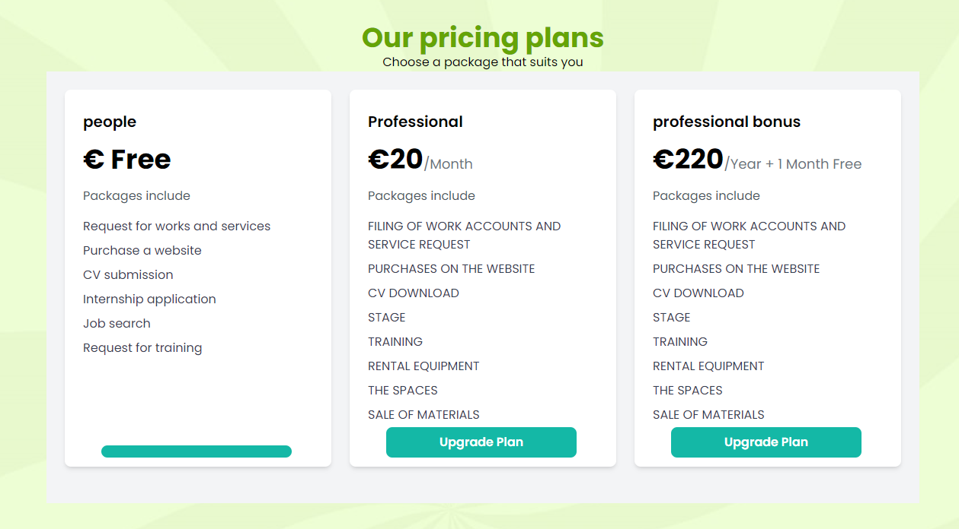



**Request Not being Uploaded (BOTH WITH PARTICULAR OR INDIVIDUAL OR PROFESSIONAL)**

Particular walay account se request upload ki but jab Professional walay account se login kar rahay tou wou request hi show nahi horahi Accueil (Homepage) pe.

Same with the Professional Account too, request upload nahi horahi (Public and Private Request) both or Public Request jo ke Accueil Page pe show honi chiyeh wou bhi show nahi horahi.

Private request messages walay box me aana chyh wo bhi nahi aa raha.

**See the Request Page:**See the request page ek tou kaam nahi kar raha error aa raha.

Upar se agar kabhi kaam kar raha tha tou ispe latest or new post ki hui request jo banda daalta wou show nahi ho rahi.

Or agar koi ho bhi rahi tou uspe **“Send a Message Now”** wala button kaam nahi kar raha.

**Offers Page:**Offers page pe jiss banday ki high demand (i.e.: higher ratings and recently most avail ki hui services wala banda) yeh aise banday ayenge pehle orr phr baad me baaki mid to lower demand walay.

Har Section category (Plumbing, Carpenting, Cleaning, etc) sab category ka alag alag section hoga iss **“Offers”** page pe or sab page pe yehi rule follow hoga.

Iss cheez ka khayal rakhiyega ke ek offer (i.e.: Plumbing) pe top offers walay samne show hongay something like 5-6 banday or baaki ko dekhne ke liye **“See All”** ka button banadijiyega uss category ke sath hi jisko click karne pe saare banday jo wo cheez (CATEGORY) offer kar rahay wo sab ajayenge.

**SOMETHING JUST LIKE THIS:**

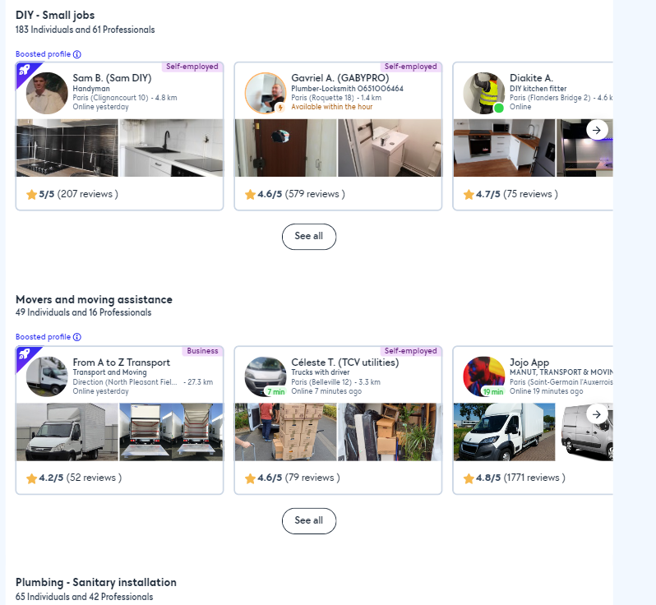

**Location Search and Proximity Search in PUBLIC REQUEST:**In the previous design or domain the Location and Proximity were mentioned (ALSO IN SRS DOCUMENT), but it doesn’t seem to be here on this website.

ONLY WITHIN FRANCE:

Location Selection:

Users search kar saktay Accueil Page pe by selecting any specific city from France (Drop Down list ke zariye, usme saari France ki cities ki list ayegi) or wou city select karne pe sirf uss city ke andar rehtay huaye logon ki public requests hi ayengi.

Proximity Search:

Users yahan se apni location select kar saktay or uss location pe (50 km) ke aas paas jitni bhi public requests hongi sirf wohi show hongi.

-

**SAME GOES WITH THE OFFERS PAGE TOO (Location Search and Proximity Search)**

**OFFERS PAGE:**

**Location Search:** Sirf wohi offers ayengi jo selected city me hongi.

**Proximity Search:** Sirf wohi offers ayengi jo selected location ki (50km) ki range me available hongi.